Database Homework
For the following database, write the queries and the result.

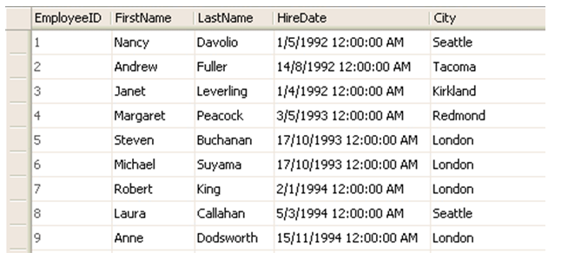

- List all the employees.
- List all employees and order by Last Name in descending order
- List all the employees and display their first name and city they are from.
- List all the employees whose last name is not ‘King’
- List all the employees who are from London
- List all the employees who are either from London or Seattle
- List all the different cities from the table
- List all the employees who have joined on or after 1-june-1992
- List all the employees who have joined between 1-june-1992 and 15-december-1993.
- List all the employees whose first name starts with ‘A’
- Count the no of rows in the table.
- Janet has relocated from Kirkland to Chicago. Reflect the change in the database.
- Laura no more works for this company. Reflect the change in the database.
- Trivia: Change EmployeeID of Michael to 10.
- Show first 5 records.

